

Eulogio “AMANG” Rodriguez Institute of Science & Technology

# COLLEGE OF INDUSTRIAL TECHNOLOGY

Valencia St., Sampaloc, Manila

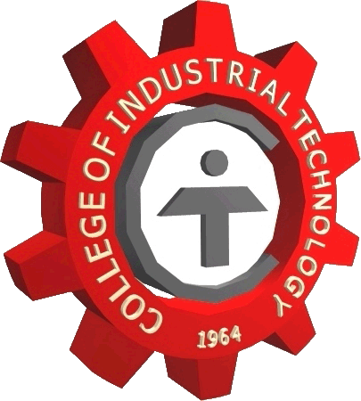

May 30, 2017

**Ms. Myrtle Balan Agulto**

Antipolo Region HR Admin Analyst

Coca-Cola FEMSA Philippines

13 Sumulong Highway, Brgy Mayamot

Antipolo City

Madam:

Good day.

In lieu to the College objective to produce graduates that will be globally competitive, our students are expected to acquire knowledge and skills in the production and manufacturing process in your company. Since they are specializing Food Technology, advantage to their potentials are the familiarity and understanding on testing product procedures through standard specification of the Company (Quality Control) and R&D Laboratory formulation and procedures.

The experience, knowledge and skills she will acquire from your company will be merited to her professional effectiveness.

Thank you and more power.

**ROBERTO E. REYNOSO**

COE Coordinator